


AB Bank Zambia

Monthly Report
May 2026

Contents
1. Executive Summary 2
1.1. Key Highlights: 2
1.1.1. Incident Volume & Trends: 2
1.1.2. Detection & Response Performance: 2
1.2. Incident Trends & Analysis: 3
1.3. High-Severity Incidents: 4
2. April Alerts & Incidents Overview 4
2.1. Overall Volume 4
2.2. Incidents Processing 5
2.3. Mean Time To Detect (MTTD) 5
3. Incidents Highlights 6
3.1. Top Incidents by type 6
3.2. Analysis of Key Incident Trends 7
3.3. High Severity 9
4. Cybersecurity Trends and Threats – Zambia (April, 2026) 10
4.1. Key Threats and Incidents 10
4.2. Regional Spillover and Infrastructure Risks 11
4.3. Government and Infrastructure Response 12
5. Conclusion and Recommendations 12
5.1. Recommendations 12
5.2. Conclusion 13

Executive Summary
This security report provides an in-depth analysis of security incidents, alerts, and operational activities managed by TeKnowledge for AB Bank Zambia during the reporting period (May 2026). The findings highlight key security trends, detection and response performance, and proactive measures taken to enhance the organization’s security posture.

Key Highlights:

Incident Volume & Trends:
A total of 1034 security incidents were generated in the Production environment and 0 Security incidents in the Test Environment. All incidents were processed in Microsoft Sentinel, encompassing both manually investigated cases and automated detections.
The most prevalent security events still include Authentication Attempt - Default Account, FortiGate Successful Login, Monitor for keylogging activity, Source Stopped Sending Data: Syslog, User Account Modified highlighting the performance of the Security Environment on Administrative account-login monitoring, User-Account Management in the Security environment, Suspicious process monitoring, VPN connection Notification and Critical-Server Operational and logging Status Notifications.

Detection & Response Performance:
Mean Time to Detect (MTTD): 2 minutes and 33 seconds, ensuring timely identification of incidents.
Additionally, the breakdown of MTTD by severity is as follows:
High Severity: 2 minute and 31 seconds
Medium Severity: 2 minutes and 32 seconds
Low Severity: 1 minutes and 46 seconds
Informational: 3 minutes and 07 seconds

Average time to First Response: The average Time to First Response was 15 minutes. See the screenshot below for the breakdown according to the incidents’ severity.
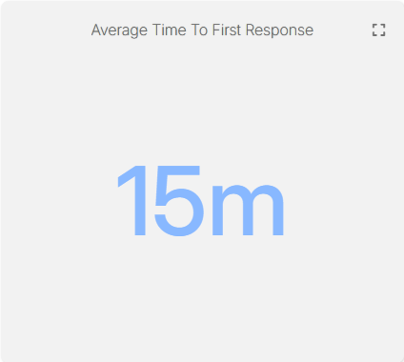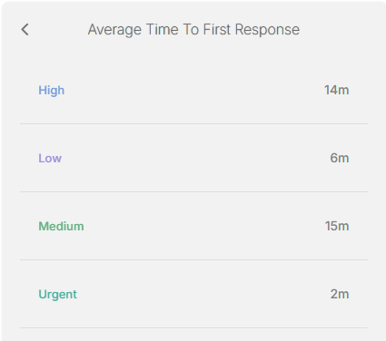
Mean Time to Resolution (MTTR): The average Mean Time to Resolution (MTTR) for this reporting period was 18 minutes. The screenshot below provides a detailed breakdown by severity.
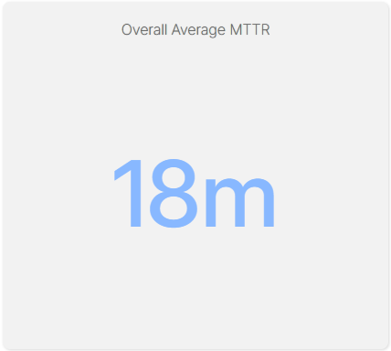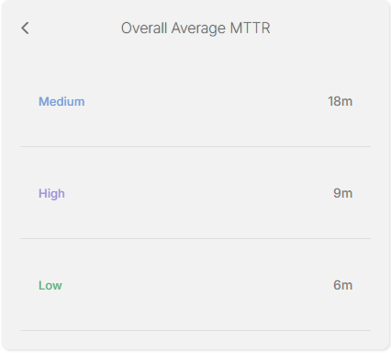

Incident Trends & Analysis:
The top recurring incident types identified in May accounted for 626 of the total incidents. These incidents were mainly tied to Authentication Attempt - Default Account, FortiGate Successful Login, Monitor for keylogging activity, Source Stopped Sending Data: Syslog, User Account Modified indicating Administrative Account Authentication Notifications, Access-Notification to VPN, Users-Account Management Notification and Log-Server Operational Status.
The most frequent alerts were related to:
- Authentication Attempt - Default Account – 236
- FortiGate Successful Login - 137
- Monitor for keylogging activity – 126
- Source Stopped Sending Data: Syslog - 68
- User Account Modified – 59
All these incidents were thoroughly reviewed and escalated where necessary, helping to maintain Operational stability and security to the critical Assets.

High-Severity Incidents:
A total of 29 alerts were categorized as high severity, which entails “Non Domain Controller Active Directory Replication” and “Preview: Possible multistage attack activities detected by Fusion”. The high-severity case confirmed to be carried out by The Dedicated Service-Account for Active Directory Replication and the multistage was of Authorized Members of the IT Team RDP into critical Servers.

April Alerts & Incidents Overview

Overall Volume
In the month of April, a total of 1034 incidents from production environment were handled on MS Sentinel. Further breakdown in severity showed that 29 were of High Severity, 932 were of Medium Severity, 14 were of Low Severity and 59 Informational Incidents. This volume includes manually processed incidents and automatically-addressed incidents: through pre-configured automation protocols.
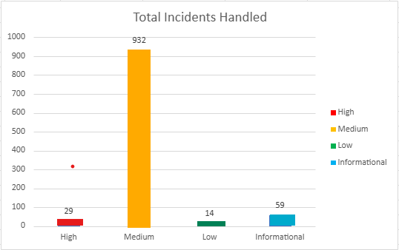

Incidents Processing
During the reporting period, TeKnowledge successfully monitored, detected, and responded to a total of 1034 security incidents within the AB Bank Zambia production environment. The SOC team processed all incidents, ensuring a comprehensive approach to threat detection and response.

Mean Time To Detect (MTTD)
The average Mean Time to Detect (MTTD) for this reporting period was 2 minutes and 33 seconds. Average detection time for High-severity was 2 minute 31 seconds, Medium-severity was 2 minutes 32 seconds, Low-severity was 1 minutes 46 seconds, and Informational incidents were averagely detected at 3 minutes 07 seconds
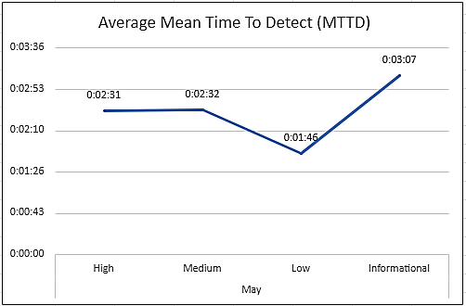

Incidents Highlights

Top Incidents by type
During the reporting period, TeKnowledge monitored security incidents, identifying the most prevalent issues within your environment. Below is a breakdown of the top incident types detected:

Incident Title | Count of Title
Authentication Attempt - Default Account | 236
FortiGate Successful Login | 137
Monitor for keylogging activity | 126
Source Stopped Sending Data: Syslog | 68
User Account Modified | 59
FortiGate Logon Failure | 59
Incident Summary Alert | 59
FortiGate Logon Failure | 47
FortiGate UTM Alerts | 37
Non Domain Controller Active Directory Replication | 30
Grand Total | 858

Analysis of Key Incident Trends
During this reporting period, TeKnowledge identified and categorized multiple security incidents within the AB Bank Zambia production environment. The breakdown below highlights key trends, notable threat patterns, and actionable recommendations to improve detection and response capabilities
- Authentication Attempt-Default Account (236 Incidents)
Description: This rule monitors authentication attempts using default accounts like "Administrator," "Root," or "Guest." It searches for specific logon event types (4624, 4625, 4768, 4771, 4648, 4801) and checks if the account being used is one of the default names.
Observations: These incidents were confirmed to be generated by legitimate service accounts dedicated to specific service in the environment.
- FortiGate Successful Login (137 Incidents)
Description: This rule detects successful logins to FortiGate's management console by parsing the Syslog messages and extracting login details like user, source IP, and destination IP.
Observation: All the VPN connections were confirmed to be from legitimate and authorized users.
- Monitor for keylogging activity (126 Incidents)
Description: This rule detects keylogging activity from Servers within the Environment.
Feedback: These were triggered from legitimate users who logged in a PRTG application and no malicious activity was found.
- Source Stopped Sending Data: Syslog (68 Incidents)
Description: This rule monitors the Syslog table for data flow and triggers an alert if the number of Syslog records drops below 1,000, indicating a potential data loss from the source.
Review: These incidents were escalated to the Network Team and discovered that the Syslog server needs Space Management
- User Account Modified (59 Incidents)
Description: This rule detects modifications made to user accounts in Active Directory by monitoring Event ID 4738. It focuses on changes to user account attributes and identifies the account and subject responsible for the modification
Observation: These User account modifications were confirmed to be carried out by authorized IT Systems Administrators.
- FortiGate Logon Failure (59 Incidents)
Description: This rule detects failed login attempts on FortiGate devices' administrative interface. It parses the Syslog messages for failure events, while excluding specific benign scenarios.
Observation: These were triggered by legitimate users who made mistakes in the login password and/or ssh error due to expired token.
- Incident Summary Alert (59 Incidents)
Description: This rule produces a summary count of incidents generated in the past 12hrs.
- FortiGate Configuration Change (47 Incidents)
Description: This rule detects configuration changes on FortiGate firewalls by monitoring Syslog messages that indicate a change and extracting details such as the user and device involved.
Observation: All changes carried out on the FortiGate Firewall was done by Authorized Member(s) of the IT/Network Admin Team.
- FortiGate UTM Alerts (37 Incidents)
Description: This rule detects FortiGate Unified Threat Management (UTM) alerts by parsing Syslog messages that contain UTM alert indicators and identifying relevant details like source and destination IPs.
Feedback: All identified malicious request was dropped by the firewall
- Non Domain Controller Active Directory Replication (30 Incidents)
Description: This query detects potential attempts by non-computer accounts (non-domain controllers) to retrieve/synchronize an active directory object leveraging directory replication services (DRS). A Domain Controller (computer account) would usually be performing these actions in a domain environment. Another detection rule can be created to cover domain controllers accounts doing at rare times. A domain user with privileged permission to use directory replication services is rare.
Observation: The Domain controller Replication activities were confirmed to be scheduled task assigned to dedicated service-account

High Severity
During the reporting period, 35 high-severity incidents were recorded.
Incident Title | Count of Title
Non Domain Controller Active Directory Replication | 28
Preview: Possible multistage attack activities detected by Fusion | 1
Grand Total | 29

- Non Domain Controller Active Directory Replication (28 Incidents)
Review: This rule detects potential attempts by non-computer accounts (non domain controllers) to retrieve/synchronize an active directory object leveraging directory replication services (DRS). A Domain Controller (computer account) would usually be performing these actions in a domain environment.
On further investigation, it was discovered that this was an authorized activity of a dedicated Service-Account for Azure AD Connect synchronization.
- Preview: Possible multistage attack activities detected by Fusion (1 Incidents)
Review: This Fusion incident triggered by our machine learning model correlates anomalous signals and suspicious activities that are potentially associated with multistage attacks on Device: s-abz-dc-03.abbank.co.zm.
On further investigation, it was discovered that a user was removed from security enabled group. The activity was carried out by an authorized Member of the IT Team.

Cybersecurity Trends and Threats – Zambia (May, 2026)
In April 2026, Zambia’s cybersecurity landscape was shaped by digital fraud risk, AI/misinformation exposure, critical infrastructure digitization, and growing tension around digital rights, cyber law enforcement, and surveillance concerns. There weren’t any widely verified April 2026 Zambia-specific ransomware breach or major enterprise data breach in reliable public sources. The strongest April signals were instead: fraudulent SIM/mobile-money ecosystems, election-period misinformation risk, digital infrastructure expansion, and cybersecurity governance around critical telecommunications infrastructure.

Key Threats and Incidents
Digital fraud and scam-linked SIM activity remained a major threat
On April 27, 2026, Lusaka Times reported that Zambia had deactivated over 90,000 fraudulent SIM cards through enhanced reporting mechanisms. This shows that scam-linked SIM activity remained a serious threat to users, especially for mobile-money fraud, SMS scams, impersonation, and account takeover attempts.
Digitalization increased exposure to fraud and cyber risk
The same April 27 report noted that Zambia is expanding digital infrastructure, including communication towers and regulatory systems, while also implementing measures to curb digital fraud. Rapid digital growth increases the attack surface for fraudsters targeting new users, underserved communities, and mobile-first services.
AI-enabled misinformation and impersonation remained a live risk after earlier fake-video cases
Although the clearest Zambia AI scam reports appeared in February and March, April’s digital-policy environment remained focused on misinformation, cyber security, data protection, and child online protection ahead of the August 2026 elections. RightsCon 2026 was initially announced as a platform to discuss cybersecurity, data protection, digital inclusion, innovation, and child online protection, showing these risks remained central in April.
No widely verified April ransomware or major enterprise breach found
Within April 1–30, 2026, I did not find a reliable public disclosure of a new Zambia-specific ransomware incident, bank breach, or large enterprise data breach. The month’s visible threat picture was mainly fraud, SIM abuse, digital rights tension, infrastructure exposure, and election-period information risk.

Digital rights and surveillance concerns intensified around cyber laws
On April 29–30, 2026, the planned RightsCon 2026 summit in Lusaka was postponed/cancelled after government cited security clearances and further consultations. Civil-society groups and digital-rights stakeholders framed the disruption as part of broader concern around censorship, surveillance, and digital freedoms. This matters for cybersecurity because trusted digital governance depends on balancing cybercrime enforcement with privacy, accountability, and rights safeguards.

Regional Spillover and Infrastructure Risks
Telecom infrastructure became more critical to national cyber resilience
Zambia’s April digitalisation update said telecommunications infrastructure has been designated as critical under the Cybersecurity Act, with a dedicated 2026 budget line to support the sector. This is positive for resilience, but it also confirms that telecom networks are now recognized as high-value targets whose compromise could affect mobile money, communication, public services, emergency response, and business continuity.
Mobile-money and SIM-based fraud remain high-probability attack paths
The deactivation of tens of thousands of fraudulent SIM cards indicates sustained abuse of mobile identities. This creates risk for smishing, fake payment alerts, SIM-swap-style fraud, mule wallet activity, and impersonation of government or bank agents.
AI and election misinformation can spill into fraud, harassment, and public disorder
Zambia’s April digital-rights discussions occurred months before the August 2026 elections. Earlier reports about fake AI videos and manipulated political content show that misinformation is not only a speech issue; it can enable phishing, impersonation, voter manipulation, harassment, and reputational attacks. April’s RightsCon controversy reinforced that digital governance and election-period cyber risk remained sensitive.
Large-scale health data consolidation expands privacy and breach risk
On April 14, 2026, SMART Zambia reported that more than 12 million patient records had been consolidated into SmartCare Pro, operational in over 2,000 health facilities. This is a major digital-health achievement, but from a threat perspective it creates a high-value data environment for attackers seeking identity data, medical records, fraud opportunities, or extortion leverage.

Government and Infrastructure Response
Telecommunications infrastructure designated as critical under cybersecurity law
The April 27 report stated that Zambia is strengthening regulatory systems and that telecommunications infrastructure is now designated as critical under the Cybersecurity Act. This is one of the strongest April response signals because it places telecom networks into a protected national infrastructure category.

Fraudulent SIM-card deactivation used as a direct anti-scam control
Government and regulators continued using SIM deactivation as a practical control against fraud. The reported deactivation of over 90,000 fraudulent SIM cards shows a concrete effort to disrupt scam infrastructure at the telecom layer.

Digital-health infrastructure scaled nationally, requiring stronger security-by-design
SmartCare Pro’s consolidation of over 12 million patient records and deployment across more than 2,000 health facilities shows Zambia’s public-sector digitization is accelerating. The response priority should be strong access control, audit logs, encryption, segmentation, backup resilience, and breach-response planning for health data.

RightsCon postponement/cancellation reflected unresolved digital governance tensions
The government announced the postponement of RightsCon 2026 on April 29, citing pending security clearances and consultations. Digital-rights groups later described the event as cancelled and raised concerns around censorship and civic participation. This is relevant because cyber policy maturity depends not only on enforcement but also trust, transparency, and accountability.

Sources: Lusaka Times(April 27, 2026) , Lusaka Times (April 26, 2026), Lusaka Times (April 29, 2026), Zambia Monitor, SMART Zambia Institute (April 14, 2026), IPPF, OMCT

Conclusion and Recommendations

Recommendations
Optimize Analytic Rules: Standardize entity mapping (Account, Host, IP, Process, File Hash, URL/Domain) across analytic rules to improve auto-grouping, speed up triage, reduce noise from non-production systems, and enhance reporting accuracy.
Expand SSH Detection: Develop additional analytic rules to increase visibility into SSH-based connections and activities, ensuring comprehensive coverage of remote-access behaviour.
Ensure Agent Resilience: Configure all log-forwarding agents to start automatically after reboots and set service recovery options to restart on failure, preventing data gaps after maintenance or outages.
Detect Log Gaps: Setup an analytic rule that flags servers with missing or delayed log data, enabling quick identification and remediation of sources that stop sending events.
Correct “Heartbeat Missing” Rule Configuration: Update the Rule Period from 30 minutes to 6 –12 hours to broaden detection coverage and configure Event Grouping to “Group all events into a single alert”.
Emphasis on WithSecure EDR Integration with Microsoft Sentinel: Integrating WithSecure EDR with Microsoft Sentinel is recommended to improve security visibility and efficiency. This integration centralizes endpoint and cloud workload security events into a single monitoring platform, enhancing situational awareness and event correlation. By unifying security data within Sentinel, organizations can streamline investigations, automate responses, and accelerate incident detection and remediation, ultimately strengthening overall threat response capabilities.

Conclusion
The May 2026 reporting period marked a significant step forward in the security operations of AB Bank Zambia, with TeKnowledge continuing to provide dedicated 24/7 monitoring, incident detection, and rapid response through the Microsoft Sentinel platform. A total of 1034 alerts were processed a significant increase from the previous month reflecting the need for optimization of the analytical rules in the environment.
The most detected threats included Authentication Attempt - Default Account, FortiGate Successful Login, Monitor for keylogging activity, Source Stopped Sending Data: Syslog, User Account Modified underscoring the need for sustained vigilance in identity/access management as well as operational status of critical assets.
TeKnowledge’s SOC demonstrated high operational efficiency, with the following key performance:
- Mean Time to Detect (MTTD): 2 minutes and 33 seconds
- Average Time to First Response: minutes
- Average Mean Time to Resolution: minutes

Alert classification indicates a well-tuned detection environment, with 978 benign positives, 17 true positives, 1 false positive, and 34 undetermined cases. While this reflects effective filtering and validation processes, further refinement of detection rules will help reduce undetermined cases and improve overall analyst efficiency.

29 high-severity incidents were recorded during this period.
As we move forward, TeKnowledge remains dedicated to strengthening your organization’s defences through:
- Continuous monitoring, rapid threat detection and Incident escalation
- Strategic improvements to rule coverage and incident handling workflows

We appreciate the trust placed in TeKnowledge to safeguard AB Bank Zambia’s digital environment and look forward to our continued partnership in building a more secure and resilient infrastructure.

